1. Navigate to <https://www.anaconda.com/products/individual>
2. Scroll below to choose the edition you want.
3. Windows environment : 64bit graphical installer python 3.7

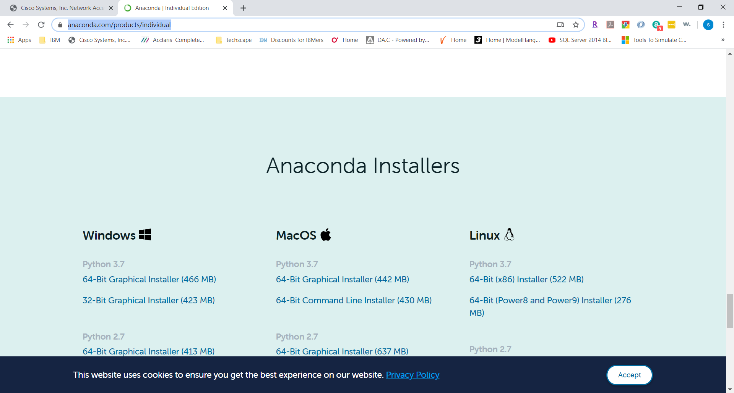

1. After download is complete dbl clik the file to start installation

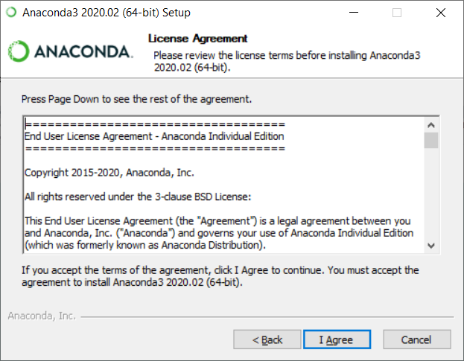

1. Clik on I agree
2. Next screen choose all users

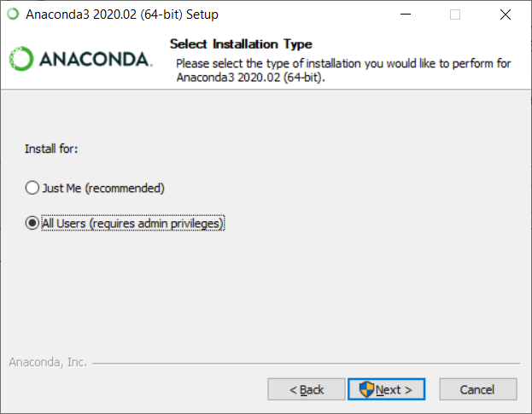

1. Say if a prompt asks you for installation and the next screen should say something like below

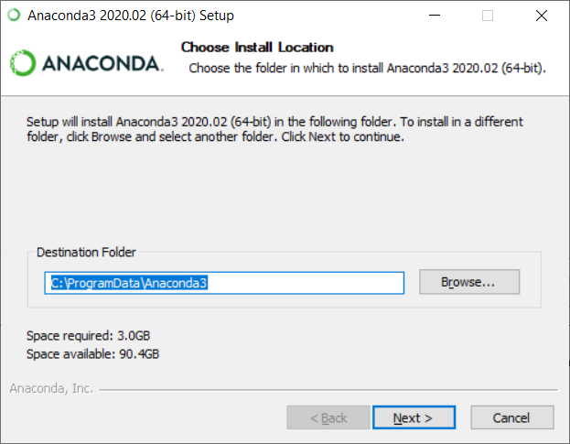

1. Choose both the boxes and ignore the warnings

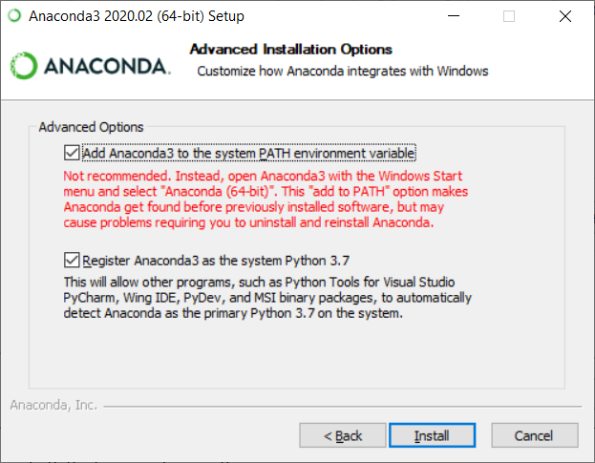

1. Choose install

The installation process will take anywhere from 10 -30 minutes or more depending on the machine speed.

1. Once it completes reboot your machine
2. After reboot : navigate to git bash icon and dbl clik it
3. The gitbash prompt opens up

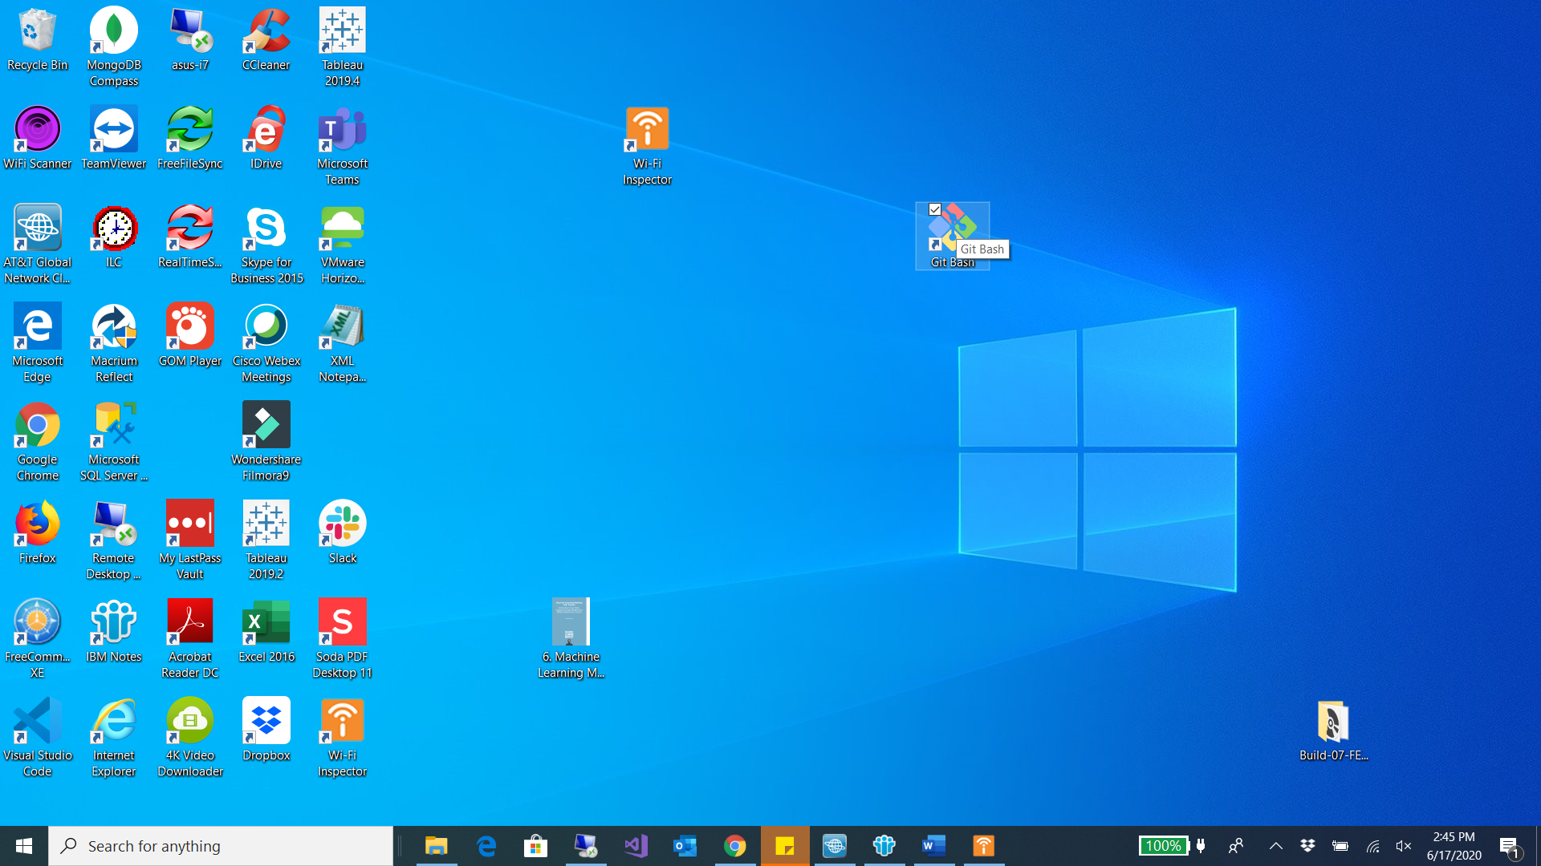

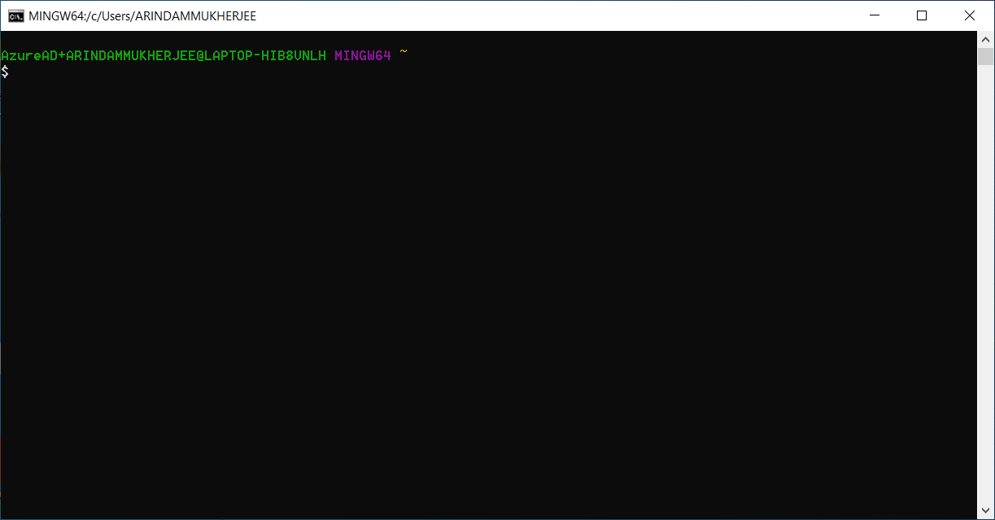

1. Type in conda –version

